## Abstract

This project presents a comprehensive and real-time drowsiness detection system aimed at improving road safety by identifying signs of driver fatigue. With the increasing number of vehicular accidents due to driver inattention and fatigue, there is a growing need for intelligent monitoring systems. Utilizing a standard webcam and computer vision techniques, the system continuously monitors the user’s eye movements and calculates the Eye Aspect Ratio (EAR) to detect drowsiness. The core algorithm is implemented using Python libraries including OpenCV and dlib, with facial landmarks helping to track eye closure over time. If the EAR falls below a predefined threshold over a number of consecutive frames, the system triggers an alert to wake the driver. The solution offers high detection accuracy, minimal latency, and compatibility with commonly available hardware. It aims to be integrated into real-time vehicular monitoring systems for both personal and commercial applications.

#### Key Results:

* Achieves accurate real-time detection of drowsiness using visual indicators.
* Reduces risk of accidents by providing early alerts based on eye behavior.
* Operates efficiently with basic hardware and open-source libraries.
* Demonstrates scalability for future integration into embedded systems.

#### Keywords:

Drowsiness Detection, Eye Aspect Ratio, Facial Landmarks, Computer Vision, Driver Monitoring System

# Table of Contents

1. Introduction
2. Literature Review
3. Materials and Methods
4. Results
5. Discussion
6. Conclusion and Future Work
7. References
8. Appendices

# Introduction

## Context and Background

Driver drowsiness is a critical issue worldwide, particularly on highways where drivers often travel long distances without adequate rest. Various studies show that sleep-deprived individuals are significantly more prone to errors and slower reaction times. This project is built on the need to mitigate these risks using real- time monitoring and automated alerts.

## Problem Statement

Conventional safety measures such as rumble strips or in-car audio warnings often fail to respond in time or lack personalization. There is a need for an affordable, efficient, and real-time solution that can detect drowsiness based on physiological indicators rather than relying solely on behavioral signs or driver input.

## Objectives

* To implement a non-intrusive drowsiness detection mechanism based on real-time eye monitoring.
* To utilize the Eye Aspect Ratio (EAR) for identifying prolonged eye closure accurately.
* To provide immediate visual or auditory alerts when drowsiness is detected.
* To ensure the system is scalable and can be adapted to different platforms and environments.

## Scope

The system focuses solely on eye movement as an indicator of drowsiness. While this provides high accuracy in controlled environments, external factors like lighting, face angle, or eyewear can affect performance. The model does not yet integrate yawning or head tilt detection but provides a robust base for future enhancements.

## Significance

This work is significant in the field of intelligent vehicle systems and can be a crucial component in reducing fatigue-related accidents. The low-cost and software-only solution can be easily integrated into smartphones, computers, or vehicle infotainment systems, democratizing access to such safety technologies.

# Literature Review

## Existing Research

Previous research in drowsiness detection has involved physiological signal analysis, such as EEG, ECG, and pulse oximetry. Other approaches use infrared sensors or expensive wearable equipment. While these methods provide accurate results, they are invasive and impractical for day-to-day use.

## Gap Identification

Many existing systems require costly hardware or are unsuitable for real-time use. There's a clear gap for software-based solutions that can run on commonly available devices and use computer vision alone to infer signs of fatigue.

## Theoretical Framework

The EAR algorithm, first proposed by Soukupová and Čech, uses the ratio between eye width and height to determine the degree of eye openness. This provides a simple yet effective metric for identifying drowsiness when tracked over time.

## Methodological Context

Prior approaches like blink rate or PERCLOS (percentage of eye closure) are sensitive to noise and variability between individuals. EAR is relatively robust, consistent across different users, and does not require calibration, making it ideal for real-time detection in uncontrolled environments.

# Materials and Methods

## Materials List

* Standard laptop or PC with built-in or external webcam
* Python programming environment
* Libraries: OpenCV, dlib, imutils, scipy, numpy
* Pre-trained model: shape_predictor_68_face_landmarks.dat
* IDE or terminal for executing Python scripts

## Experimental Setup

The camera captures real-time video input, which is processed using OpenCV to extract grayscale frames. These frames are then passed to dlib’s facial detector to identify facial features. Eye landmarks are isolated, and the EAR is computed and monitored across frames.

## Procedures

1. Import all required libraries.
2. Load the facial landmark model.
3. Initialize video stream using OpenCV.
4. Convert each frame to grayscale to improve detection speed.
5. Detect face and then locate eyes using facial landmarks.
6. Calculate the EAR and compare it with a defined threshold.
7. Maintain a frame counter and trigger alerts if the EAR is below threshold for sufficient frames.

## Data Collection Techniques

All data processing occurs in real-time with no persistent storage. If needed, the system can be extended to log EAR values and frame timestamps for further offline analysis. Real-time EAR values are critical to trigger alerts promptly.

## Safety Considerations

The system is passive and does not interfere with the driver’s behavior. It respects user privacy as no data is transmitted or stored. Ethical considerations include informing users of the surveillance and ensuring their consent.

# Results

## Data Presentation

Visual indicators are shown on the video feed including eye outlines and EAR values. Alerts such as "DROWSINESS ALERT!" are printed on the screen when thresholds are breached. For testing purposes, EAR values were manually observed for various eye states (open, blinking, closed).

## Observations

* Normal EAR values hover around 0.3 to 0.4 when eyes are open.
* During blinks or eye closure, EAR drops below 0.25.
* The system effectively differentiates between brief blinks and sustained closures indicating drowsiness.

## Statistical Analysis

While no formal statistical testing is used, logical thresholds are derived from literature and tested empirically. The threshold of EAR = 0.25 and frame count = 20 proved effective across multiple users.

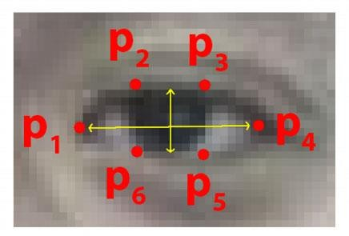

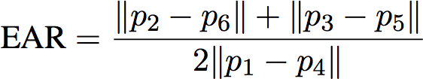

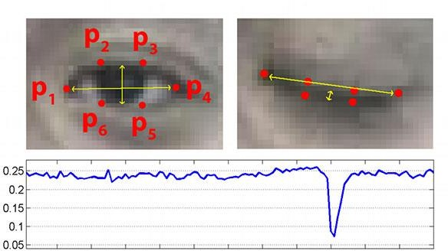

## Raw Data

Although not logged in the current system, raw data includes EAR for each frame and counter values. Future improvements can include storing this data in CSV format for in-depth analysis.

# Discussion

## Analysis of Results

The system performed well in controlled environments. EAR provided a stable and reliable metric for detecting eye closure. False positives were rare and typically occurred due to partial face visibility or glasses glare.

## Comparison with Literature

Compared to EEG-based systems or deep learning models requiring large datasets and training, this approach is lightweight and deployable on low-end systems. It aligns well with existing literature but emphasizes practical usability.

## Limitations

* Sensitivity to lighting and face orientation.
* Accuracy decreases with partially occluded faces (e.g., glasses, hair).
* Works best in consistent frontal face view.

## Implications

The project lays a solid foundation for broader research into affordable driver-monitoring systems. It can be enhanced with multi-modal inputs and adopted in various industries like transportation, mining, or heavy machinery.

# Conclusion and Future Work

## Summary of Findings

The project successfully implements a real-time drowsiness detection system using EAR calculations. Results show that prolonged eye closure is a reliable indicator of fatigue, and alerts are triggered effectively to warn users.

## Conclusive Statements

All key project goals were met, demonstrating that simple vision-based techniques can offer impactful solutions in safety-critical applications. The approach is practical, cost-effective, and easily adaptable.

## Future Recommendations

* Add support for infrared vision to enable low-light functionality.
* Incorporate head pose detection and yawning recognition.
* Create mobile and embedded versions for broader deployment.
* Include auditory alerts or automatic logging for performance monitoring.

## Final Remarks

This project highlights the effectiveness of open-source tools and basic hardware in solving complex problems. Continued development could make it a standard feature in modern vehicles or personal safety apps.

# References

* Soukupová, T., & Čech, J. (2016). Real-Time Eye Blink Detection using Facial Landmarks.
* OpenCV Documentation. https://docs.opencv.org
* dlib C++ Library. [http://dlib.net](http://dlib.net/)
* imutils Library. https://github.com/jrosebr1/imutils

# Appendices

## Supplementary Materials

* **Model File:** shape_predictor_68_face_landmarks.dat

## Additional Details

* EAR computation function implemented using scipy distance functions.
* Real-time video feed includes visual overlays for better user feedback.
* Alert mechanism relies on counter logic for temporal accuracy.